From: https://www.zerohedge.com/markets/deep-ship-deep-dive-supply-chain-crisis

The Ship [Shape] of Things to Come? (Container 5 of 6)
US maritime history in particular holds some clear lessons for today’s shipping world if looked at carefully.
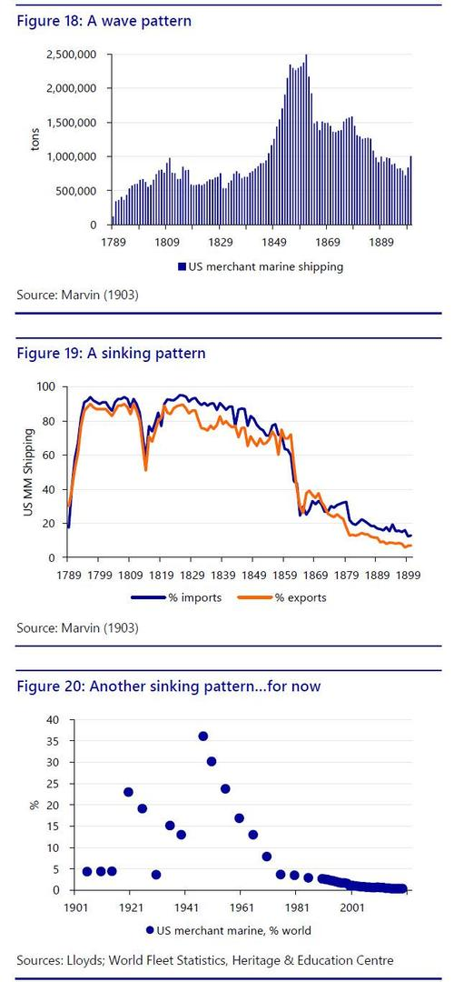
First, the importance of the sea to what we now think of as a land-based US: the US merchant marine helped it win independence from the powerful naval forces of the British, and the first piece of legislation Congress passed in 1789 was a 10% tariff on British imports, both to build US industry and merchant shipping.
Indeed, the underlying message of US maritime history is that the US is a major commercial force at sea – but only when it sees this as a national-security goal.
Following independence, US commercial shipping and industry surged in tandem, with an understandable dip only due to war with the British in 1812. The gradual normalisation of maritime trade with the UK after that saw a gradual decline in the share of trade US shipping carried, which accelerated with the end of steamship subsidies --which the British maintained-- and the US Civil War.
By the start of the 20th century, W. L. Marvin was arguing: “A nation which is reaching out for the commercial mastery of the world cannot long suffer nine-tenths of its ocean-carrying to be monopolized by its foreign rivals.” Yet 1915 saw the welfare-focused US Seaman’s Act passed and US flags move to Panama, where costs were lower. However, WW1 saw US shipping surge, and the Jones Act in 1920 reaffirmed ‘cabotage’ – only US flagged and crewed vessels can trade cargo between US ports.
The 1930s saw global trade and the US maritime marine dwindle again – until 1936, when the Federal Maritime Commission was set up "to promote the commerce of the US, and to aid in the national defense." WW2 then saw US mass production of Liberty Ships account for over a third of global merchant shipping – and then post-1945, this lead slipped away again, and the US merchant marine now stands at around just 0.4% of the world fleet.
Indeed, in 2020, US sealift capability was reported short on personnel, hulls, and strategy such that the commercial fleet would be unlikely to meet the Pentagon’s needs for a large-scale troop build-up overseas. As we see, the US has been here several times before. If the past is any guide for the future response, this suggests the following US actions could be seen ahead:
- Use its market size to force shippers to change pricing – which may already be happening;
- Raise tariffs again (on green grounds?);
- Refuse to take goods from some foreign ships or ports;
- Force vessels to re-flag in the US, at higher cost;
- Build a rival to China’s marine BRI with allies;
- Massive ship-building, for the 3rd time in the last century;
- Charter US private firms to bring in green materials; or
- The US Navy stops protecting some sea lanes/carriers, or forces the costs of their patrols onto others.
It goes without saying that any of these steps would have enormous implications for global shipping and the global economy – and yet most of them are compatible with both the strategic military/commercial logic previously underlined, as well as the lessons of history.

